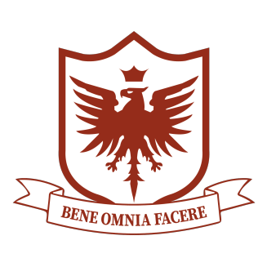
St. Peregrine Academy
3086 West Streetsboro Rd.
Richfield, Ohio 44286
(330) 659-6242
www.stperegrines.com

St. Peregrine Academy is located on the same grounds as St. Peregrine Catholic Church in beautiful Richfield, Ohio. Mass is offered three times a week by our pastor Father Joseph Budds, who resides in Walton, Kentucky. Our school recently commemorated its twentieth anniversary, and our newly constructed parish church was consecrated by Bishop Fellay in May, 2022. Our academy currently has 33 students enrolled in PreK through Grade 8. Our parish and our academy are growing. While we remain a mission church, there is a vibrant parish life to be enjoyed at St. Peregrine with a large and active young adult group, First Saturday lecture series, and more.

For the 2024-2025 academic year, St. Peregrine is seeking a full-time teacher for Grades 7-8. This is a combined-grades classroom.

Required Qualifications:
- Bachelor’s Degree
- Ability to teach all English Language Arts subjects and History for Grades 7 and 8
- Strong organizational skills
- Strong interpersonal communication skills
- Mature faith and loving disposition

Desired Qualifications:
- Prior teaching experience
- Familiarity with Society philosophy of education
- Willingness to attend Catholic Teachers’ Seminar during Summer 2024 in St. Mary’s, Kansas, paid by St. Peregrine (ten days)
- Willingness to take an online training course for Spell to Write and Read program, paid for by St. Peregrine (one weekend)

Duties:
- Write syllabus for the school year for each subject taught, including book list, to be submitted by August 1, 2024
- Write and submit weekly lesson plans to Academic Supervisor
- Attend faculty meetings and departmental meetings as scheduled
- Assess, record, and report students’ academic progress using online grade book each week
- Hold parent-teacher conferences in November with each family, and as needed throughout the year
- Help to write intervention plans for students who need them, and see that any scaffolding/accommodations are applied consistently
- Share lunch and recess supervision duties with other staff

For Our Teachers:
- Salary is negotiable, and based on experience and qualification. We are pursuing a Non-Public Charter designation, which we expect will be awarded sometime during the 2024-2025 school year, and which will enable salary increases mid-year.
- Teacher housing is often available, and we are always willing to give our assistance to a teacher who is searching for lodging.
- Our teachers' mental health and happiness are prioritized! All our teachers enjoy at least one planning period every day. We find substitutes when teachers need to take PTO. Administrators are here to help you with everything from lesson planning to conferences.

Resumes can be sent to Fr. Joseph Budds, Pastor: j.budds@fsspx.email
Please include two references.

